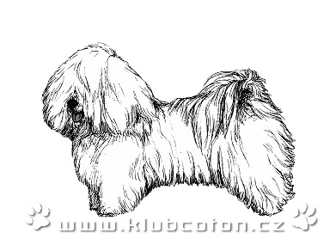
KLUB COTON DE TULÉAR
Identification Number (ID): ^{*)}

Member registration card/Application
Year: 2024
^{*)} it is stated when renewing the membership
Personal Information:
First Name, Surname: |  | Birthdate^{**)}:
Address -Street: |  | No.:
City: |  | Postal Code:
e-mail: |  | Phone No.:
www:
kennel:
^{**)} optional data

Data on owned dogs / bitches ^{***)}:
No. | Full name of the dog/bitch: | Active breeding dog/bitch: ^{****)}
1.
2.
3.
4.
5.
6.
7.
^{***)} If you own more than one dog, list the dogs on a separate sheet and attach it to the registration sheet . Mark as ENCLOSURE.
^{****)}Mark with a cross that:
the dog meets the conditions for breeding and you offer him for mating/that the bitch meets the conditions for breeding

Consents provided:
AGREE (check) / DISAGREE (leave checkbox blank)

I agree that the KLUB COTON DE TULEAR, z.s. (hereinafter to as the „Klub“), with its registered office Chrudim 538 31, Medlešice 221, IČO 65400534, in accordance with č. 101/2000 Sb. on the protection of personal data, can process my address and identification personal dasta for its own needs. This consent is valid through the duration of my membership at the Klub Coton de Tuléar.

I agree with the publication of my kennel contact (name of kennel owner, address, telephone, e-mail, www) on the Club´s publicly accessible website

I agree with the publication of the contact on my beeding dog´s card (dog owner´s name, address, phone, e-mail, kennel website) in the secured section of the Club´s website.

I agree to the Statutes, Rules of Registration and other binding regulations of the Club, ČMKU a FCI, and I will respect them.

Notes, clarifications:

Filled in by: Date:

